PHASE 5 – PROJECT DEVELOPMENT
1. Introduction
The Project Development phase focuses on implementing the **LegalEase: AI-Powered Legal Document Generator** based on the requirements, system design, and project plan defined in the previous phases.
The development process includes the implementation of the Generative AI integration, FastAPI backend, Streamlit frontend, legal document generation, document preview, editing, formatting, and export functionality.
The major development components of LegalEase are:
* Generative AI integration
* FastAPI backend
* Streamlit frontend
* Legal document generation
* Document preview and editing
* TXT, DOCX, and PDF export
* Document formatting and branding
2. Development Environment Setup
The LegalEase application is developed using Python and the required libraries and frameworks.
The development environment includes:
* Python 3.10+
* FastAPI
* Uvicorn
* Streamlit
* Google Generative AI SDK
* python-docx
* FPDF
* Pillow
* Requests
* python-dotenv
The required packages are installed using pip.
“text
pip install fastapi uvicorn streamlit python-docx fpdf Pillow requests google-generativeai python-dotenv”
A virtual environment is used to maintain the project dependencies separately.
The Gemini API key is configured using a `.env` file so that sensitive credentials are not directly included in the application source code.
3. Milestone 1 – Model Selection and System Architecture
The first development milestone focuses on selecting the Generative AI model and implementing the application architecture.
The selected model is Gemini 1.5 Pro through the Google Generative AI SDK.
The LegalEase architecture consists of:
* Streamlit frontend
* FastAPI backend
* Gemini AI integration
* Document formatting modules
* TXT, DOCX, and PDF outputs
The frontend collects the required legal information and sends it to the FastAPI backend. The backend communicates with the Gemini AI component to generate the required legal document.
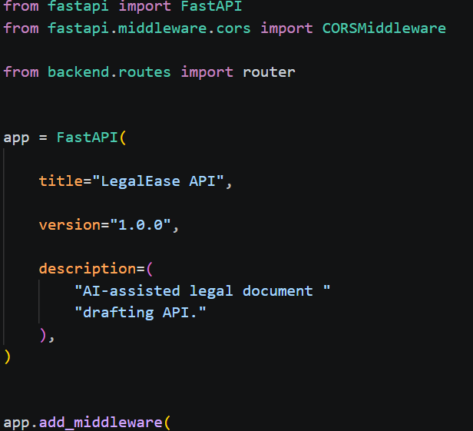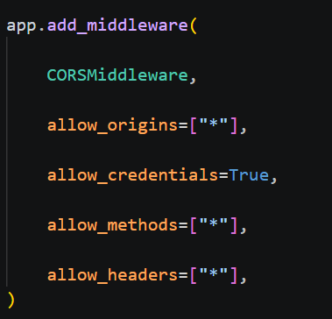

4. Milestone 2 – Core Functionalities Development
The second milestone focuses on implementing the core functionalities of LegalEase.
4.1 Legal Document Generation
The document generation functionality accepts the following user inputs:
* Document type
* Parties involved
* Terms and conditions
* Effective date
These inputs are processed and provided to the Gemini model for generating structured legal content.
The system can generate documents such as:
* Employment Contracts
* Non-Disclosure Agreements
* Lease Agreements
* Contracts
* Other agreements
4.2 User Input Interface
The Streamlit frontend provides input fields for collecting the required legal information.
The main input fields are:
* Document Type
* Parties
* Terms & Conditions
* Effective Date
The interface also provides the Generate Document option.
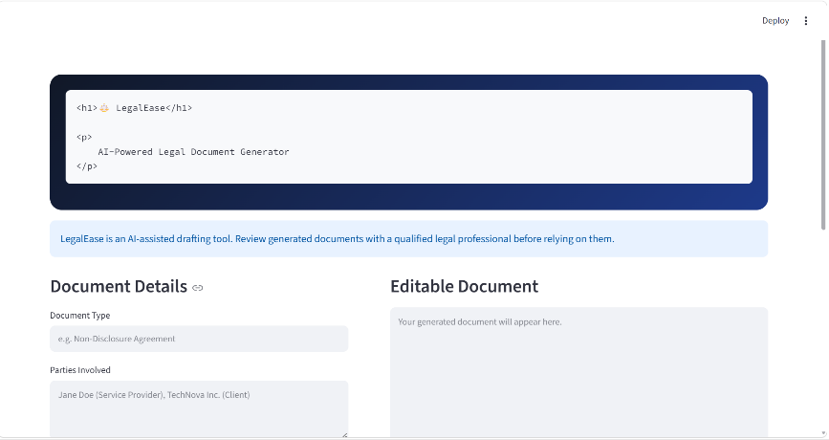
4.3 AI-Based Document Generation
When the user selects **Generate Document**, the entered information is sent to the FastAPI backend.The backend processes the request and communicates with the Gemini document generation component.The AI component creates a structured prompt using the user-provided information and sends it to Gemini for document generation.
The generated legal content is then returned to the frontend.
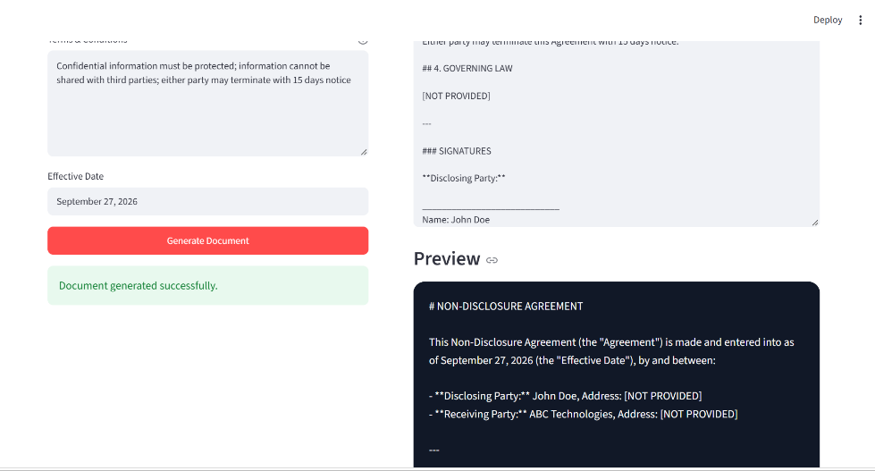
5. Milestone 3 – API Logic Integration
The third milestone focuses on implementing the FastAPI backend and connecting it with the AI generation component.
5.1 main.py Implementation
The `main.py` file is used to initialize and configure the FastAPI application.
The main responsibilities include:
* Initializing the FastAPI application.
* Defining the root `/` endpoint.
* Including routes from `routes.py`.
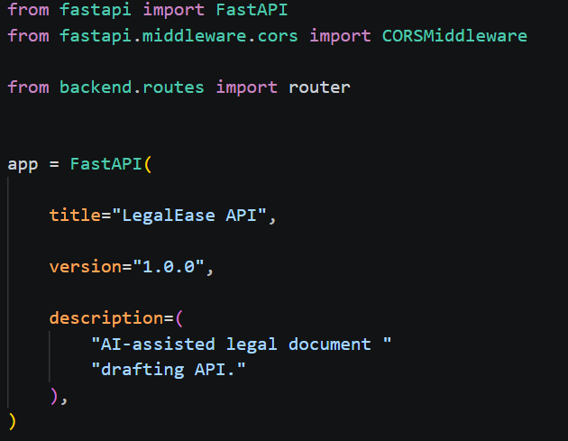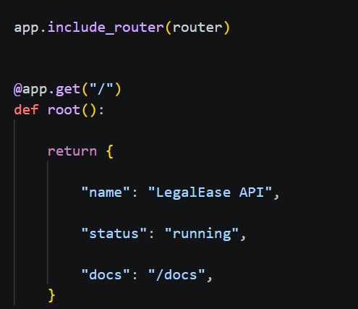
5.2 routes.py Implementation
The `routes.py` file handles the document generation API logic.
The implementation includes:
* `DocumentRequest` Pydantic model.
* Input validation.
* POST `/generate` endpoint.
* Initialization of `GeminiDocumentGenerator`.
* Processing of document generation requests.
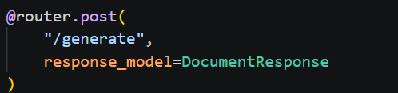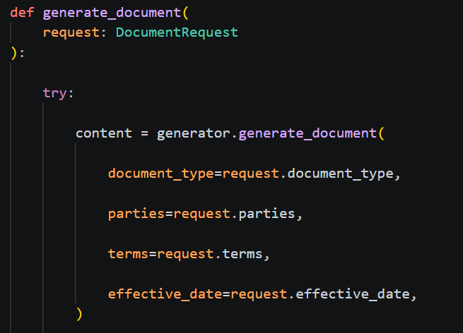
5.3 Gemini AI Integration
The Gemini integration is implemented through the AI core component.
The `GeminiDocumentGenerator` forms a structured prompt using the document requirements and sends the request to the Gemini model.The generated content is returned to the FastAPI backend and then displayed by the Streamlit frontend.

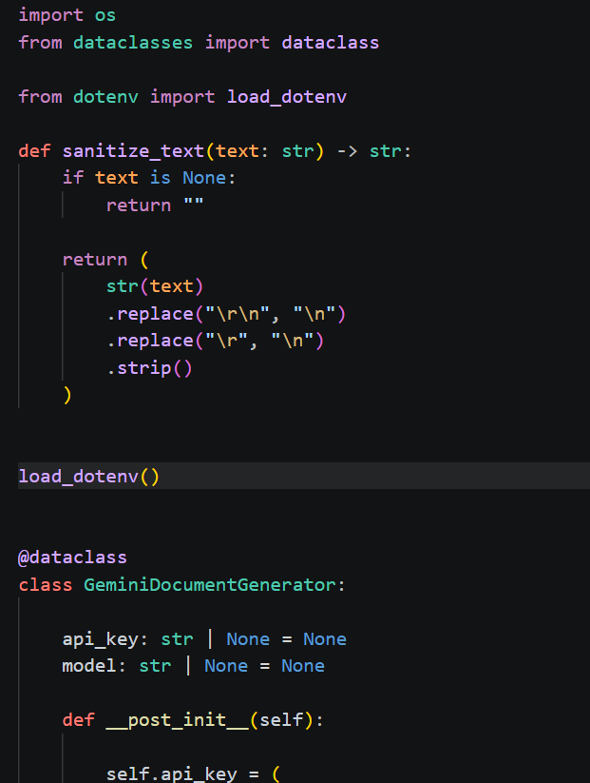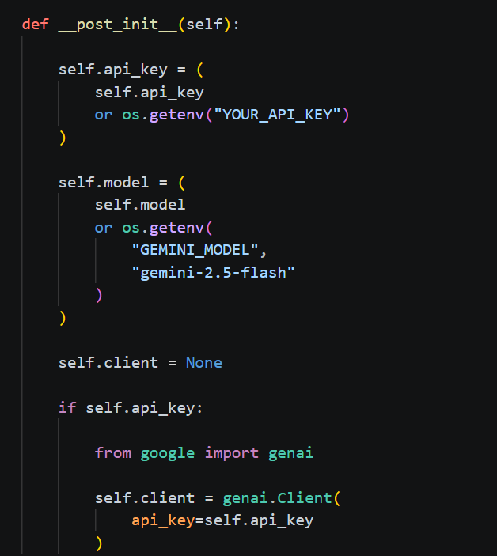
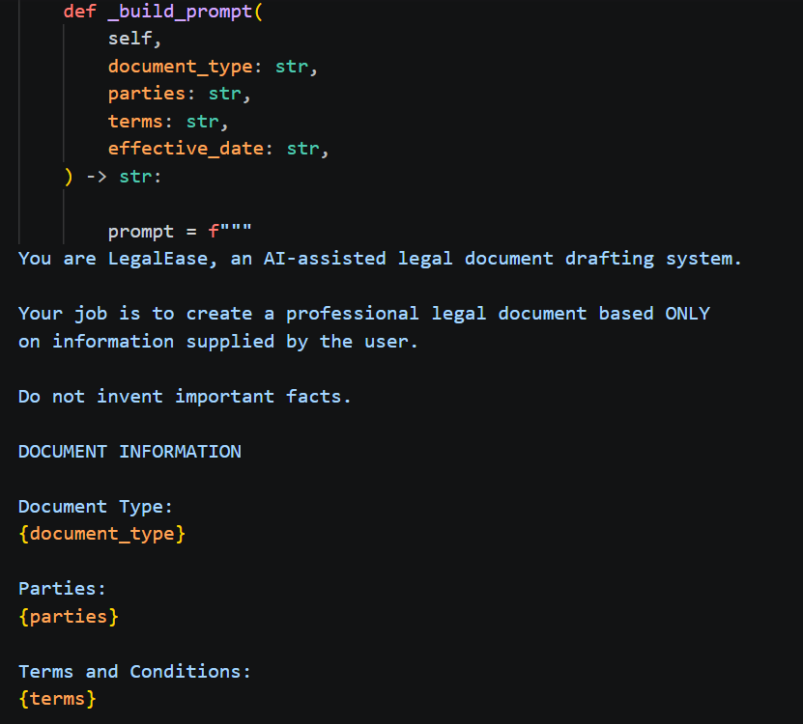
6. Milestone 4 – Frontend Development
The fourth milestone focuses on developing the LegalEase user interface using Streamlit.
6.1 Page Configuration and Layout
The Streamlit application is configured with a user-friendly layout. A three-column layout is used to position the application logo and provide a structured interface.
The application includes:
* Project logo
* Project title
* Input fields
* Action buttons
* Document preview
* Editing area
* Download options
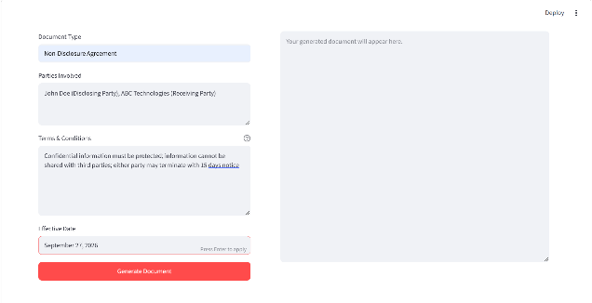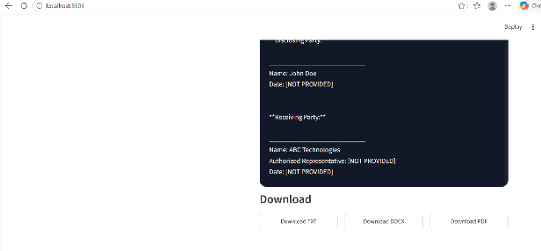

6.2 Header and Title
The application displays the LegalEase branding through the project logo and title.The header provides users with a clear identification of the application before entering the required information.
6.3 Dynamic Document Generation
When the user clicks Generate Document, the Streamlit frontend sends a POST request to the FastAPI backend.The backend processes the request and returns the AI-generated content.The generated content is then displayed dynamically in the frontend.
7. Document Preview
LegalEase provides a styled HTML preview of the generated legal document.The generated content is converted into a formatted HTML representation and displayed within the Streamlit interface.The preview allows users to review the generated content before downloading it.The preview interface uses a scrollable document display for viewing the generated legal content.
8. Editable Document Functionality
The system provides an editable document option.When the user selects Edit Document, the generated content is displayed in an editable text area. The user can modify the content according to their requirements before exporting the final document.
9. Document Formatting and Export
LegalEase provides multiple document export options.
The generated document can be downloaded in:
* `.txt`
* `.docx`
* `.pdf`
Separate formatting functions are used for the different document formats.
9.1 TXT Format
The TXT format provides the generated legal content as plain text.
It is suitable when the user requires a simple text version of the generated document.
9.2 DOCX Format
The DOCX format is generated using the `python-docx` library.
The document can include:
* Logo
* Document title
* Paragraph formatting
* Terms table
* Footer
The `format_docx(text, doc_type)` function is used for creating the formatted Word document.
9.3 PDF Format
The PDF format is generated using the FPDF library.
The PDF document can include:
* Logo
* Section headings
* Bullet-style terms
* Header/footer
The `format_pdf(text, doc_type)` function is used to create the formatted PDF document.
9.4 Download Options
The application provides download options for all supported formats.Users can select the required format and save the generated document.
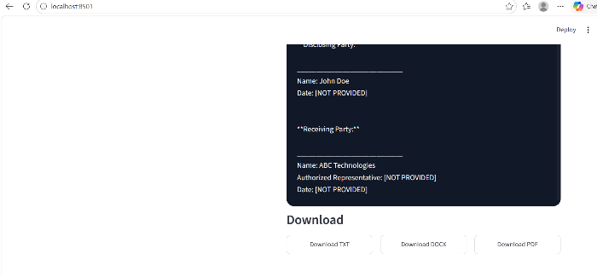
10. Core Functions and Utilities
The LegalEase application uses specific utility functions to process and format the generated content.
10.1 sanitize_text()
The `sanitize_text(text)` function removes special characters and typographic quotes to ensure clean and consistent document formatting.
10.2 format_docx()
The `format_docx(text, doc_type)` function generates a formatted DOCX document using `python-docx`.
It supports:
* Logo embedding
* Titles
* Paragraph formatting
* Terms table
* Footer

10.3 format_pdf()
The `format_pdf(text, doc_type)` function generates a PDF document using FPDF.
It supports:
* Center-aligned logo
* Section headings
* Bullet-style terms
* Header/footer
10.4 format_html_preview()
The `format_html_preview(text)` function converts generated content into styled HTML blocks for displaying the document within the Streamlit interface.
11. Complete Development Workflow
The complete implementation workflow of LegalEase is:
User enters document details
↓
Streamlit Frontend
↓
POST `/generate` Request
↓
FastAPI Backend
↓
DocumentRequest Validation
↓
GeminiDocumentGenerator
↓
Gemini AI
↓
Generated Legal Content
↓
HTML Preview
↓
Edit Document
↓
TXT / DOCX / PDF Formatting
↓
Download Final Document
12. Local Deployment Preparation
After implementing the major functionalities, the application is prepared for local deployment.
The deployment preparation includes:
1. Creating a virtual environment.
2. Installing required dependencies.
3. Preparing `requirements.txt`.
4. Configuring the `.env` file.
5. Adding the Gemini API key securely.
6. Starting the FastAPI backend using Uvicorn.
7. Starting the Streamlit frontend.
8. Verifying communication between the frontend and backend.
13. Local Application Verification
The complete application workflow is verified in the local development environment.
The verification includes:
* Entering document type.
* Entering parties.
* Entering terms and conditions.
* Entering effective date.
* Generating the document.
* Viewing the generated document.
* Editing the document.
* Downloading TXT.
* Downloading DOCX.
* Downloading PDF.
* Checking document formatting.
14. Conclusion
The Project Development phase implemented the major components of the LegalEase: AI-Powered Legal Document Generator.
The FastAPI backend was developed to process document generation requests, while the Streamlit frontend provides the user interface for entering legal information, generating documents, previewing results, editing content, and downloading documents.The Gemini AI integration enables dynamic legal document generation, while the document formatting functions provide TXT, DOCX, and PDF outputs. The completed implementation provides the foundation for testing the application in the next phase.

